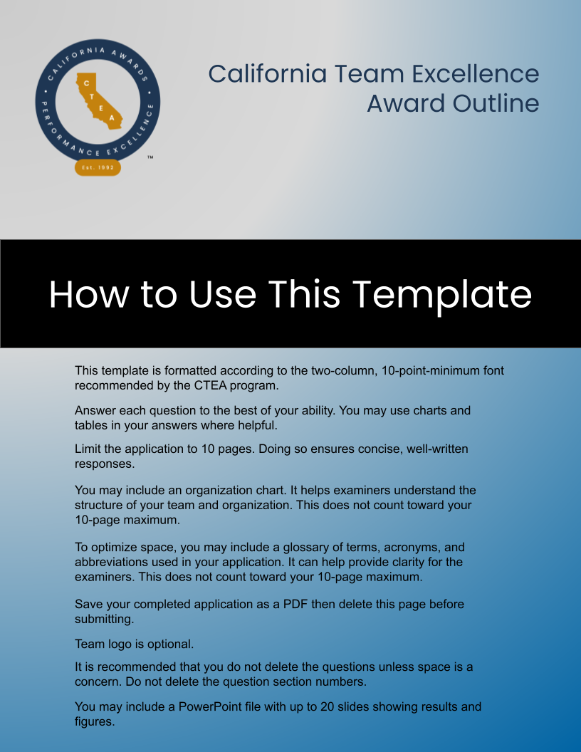

PROFILE

P.1 Organizational Profile
In this section, please provide the broader organizational context for your team. In section P2, you will have a chance to answer questions about your specific team.

P.1-1. What are your organization’s main product/service offerings?

P.1-2. What are your organization’s Mission, Vision, and Values?
If your organization has a stated purpose as well as a mission, you should include it in your response. Some organizations define a mission and a purpose, and some use the terms interchangeably. In some organizations, purpose refers to the fundamental reason that the organization exists. Its role is to inspire the organization and guide its setting of values.

P.1-3. What is your organization’s performance improvement system?

P.2 Team Profile
P.2-1. Where does the team fit within the organization (an organizational chart may be provided)?

P.2-2. What is the purpose of the team? Is there a problem the team is trying to solve? If so, what is the problem?

P.2-3. Why is the team important to the organization?

P.2-4. What are the team’s project/process goals?

P.2-5. What are the team’s key customer and stakeholder groups (i.e., who will use or benefit from the project/process your team provides)?

LEADERSHIP

1.1 Senior Leadership

The team’s executive sponsor(s) can be a leader at any level of the organization who has the authority to enable the team to operate and who will support and defend the team when necessary.
1.1-1. How does the team secure executive sponsorship/senior leader support?

1.1-2. How does the team’s executive sponsor/senior leader support the purpose and outcome of the team?

1.2 Team Leadership
1.2-1. How does the team leader create focus to ensure the success of the team’s project/purpose?

1.2-2. How does the team leader seek input from all team leaders?

1.2-3. How does the team make decisions?

1.2-4. How are internal/external experts integrated with the team?

1.2-5. How does the team leader communicate about team progress including: goals, project/process status, action plans, etc.?

STRATEGY
2-1. How does the team develop its strategy?

2-2. How does this team determine key short- and long-term action plans?

2-3. How does the team determine key deliverables?

2-4. How does this team’s project/process align with areas of importance (i.e., Organization’s Mission, Mission, Values, etc.)?

2-5. How does the team ensure that adequate resources (financial & personnel) are available to support the completion of the project/process?

CUSTOMERS
3-1. How does the team listen to customers to obtain actionable information?

3-2. How does the team determine customer/stakeholder needs and requirements?

3-3. How does the team build and manage customer/stakeholder relationships?

3-4. How does the team determine customer/stakeholder satisfaction, dissatisfaction, and engagement?

3-5. How does the team determine if the project/process meets customer/stakeholder needs and requirements?

3-6. How does the team use VOICE-OF-THE-CUSTOMER and market data and information?

MEASUREMENT, ANALYSIS, REVIEW AND KNOWLEDGE MANAGEMENT
4-1. What key performance measures or indicators does the team use to track the achievement and effectiveness of the team’s goals and plans?

4-2. How does the team measure and analyze data and information to improve the project/process?

4-3. How does the team transfer relevant knowledge to key stakeholders?

4-4. How does the team share their best practices with the organization?

4-5. How does the team use their knowledge and resources to stimulate learning in the organization?

PROJECT WORKFORCE
5-1. How does the team build an effective and supportive environment to accomplish its goals and action plans?

5-2. How does the team assess the right expertise and skills represented on the team?

5-3. How do team members receive the necessary training to complete the project/process?

5-4. How does the team remain engaged and focused on accomplishing the team goals and action plan(s)?

5-5. How is the team’s effectiveness and efficiency evaluated?

OPERATIONS
6-1. How does your team determine your key work products and processes?

6-2. How do you ensure the team’s key work products and processes meet the requirements of the customer/stakeholders?

6-3. What are your key support processes and how were they determined?

6-4. How do you make meaningful change to create value for customers/stakeholders (i.e., innovation)?

6-5. How does the team ensure effective management of the project/process?

6-6. How do you manage the cost of the team project/process?

RESULTS
7-1. What are the results of the team’s project/process? Results presented should align to performance measures identified within the application.

7-2. What are the team’s process effectiveness and efficiency results?

7-3. What are the team’s customer/stakeholder satisfaction and dissatisfaction results?

7-4. What are the team’s customer/stakeholder engagement results?

7-5. What are the results for measures of team engagement and satisfaction?

7-6. What are the results for team leader communication and engagement with the team, customers/stakeholders?

7-7. What are the team’s financial results related to the project/process (i.e., cost savings, adherence to budget, etc.)?

7-8. What are the results for the achievement of the team’s strategy and action plans?

