California Awards for Performance Excellence (CAPE)
Pre-Work Assignment Scorebook

Examiner’s Name:
Number of Hours Worked:

2024 Examiner Training Pre-Work Assignment Instructions

The purposes of this assignment are (1) to prepare you to fully participate in the live facilitated training experience, and (2) to become familiar with the Baldrige Framework for Performance Excellence. The assignment will take you up to 25 hours to complete. If you do not complete the assignment, you will not be allowed to participate in the facilitated training sessions and training will be non-refundable.

Completed assignments will be reviewed by training facilitators prior to the first day of the live facilitated sessions and used throughout the training during team exercises. The more diligent you are in completing your assignment, the greater the benefit you and your classmates will get from the training.

Materials you will need to complete your case study assignment: Materials can be accessed within the online course or downloaded from the Examiner Training Resource page.
- Case Study: This is a sample Baldrige Award application showing a fictitious organization’s responses to the requirements of the Baldrige Excellence Framework.
- Baldrige Excellence Framework (Health Care): The Baldrige Excellence Framework, includes the criteria you will use to complete your pre-work assignment. This document is only available on the online training course platform.
- CAPE Pre-Work Assignment Scorebook (this document): The scorebook will be used to capture all your work for the pre-work assignment. The scorebook also contains the Key Factors Worksheet template.
- Additional Resources/Examples (found within the online training or on the Examiner Resource page):
  - ADLI/LeTCI Overview
  - Comment Guidelines
  - Example of Partially Completed Key Factors Worksheet
  - Example of Process Item 5.1 and Results Item 7.3 Worksheets
Steps to complete your pre-work assignment:
- Read the Case Study from cover to cover – make notes and highlight as you read.
- Read the Baldrige Excellence Framework (Education) from cover to cover.
- Read the Case Study Organizational Profile and complete the Key Factors (KFs) Worksheet (KFs Worksheet template starts on page 5 of this document).
- Complete an item worksheet for each of the four criteria items assigned (Items 3.2, 5.1, 7.2 and 7.3).
- Upload your completed CAPE Pre-Work Assignment Scorebook (this document) in the online course platform two weeks before the first day of your live facilitated training sessions.

Questions: Contact California Council for Excellence at hello@calexcellence.org or (858) 486-0400 with any questions you have regarding the assignment.
How the Scorebook Works
1. From your completed Key Factors Worksheet, list the 4-6 most significant key factors related to the criteria for this item. These will help you to determine the relevance or importance of your comments to the applicant for this item. They will be used to help build a full comment during training, so make sure you are thoughtful in identifying the key factors for this item.
List the 4 – 6 most significant key factors (KFs) for this Item
1.
2.
3.
4.

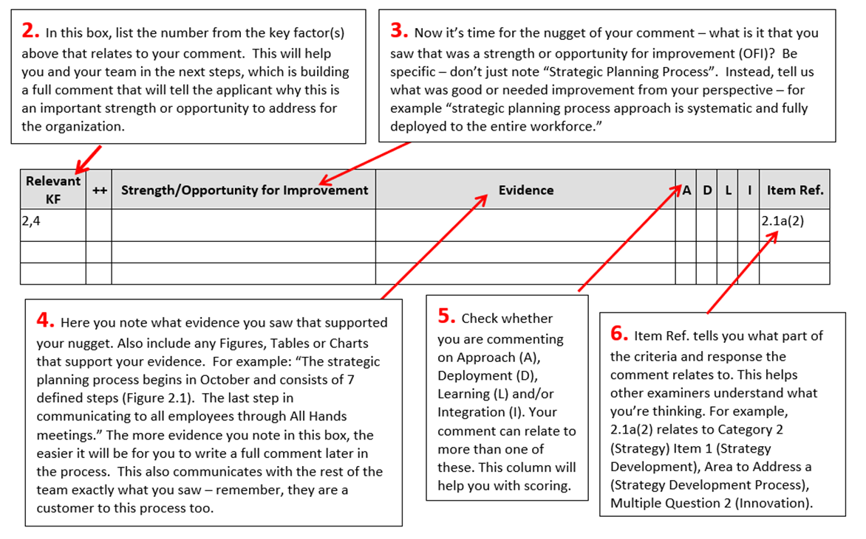
Feedback Ready Comment
The next step in the process is to write a feedback ready comment that will fully convey to the applicant what you and your team saw that was a strength or opportunity for improvement. Below is an example:
Feedback Ready Comment: |  | Item Ref.
Nugget (criteria language): | The applicant’s systematic approach to conduct strategic planning (Figure 2.1) includes key stakeholder groups. | 2.1a(2)
Evidence(from the case study): | The 7-step process begins with affirming the mission, vision, values, and core competencies. Other key steps include review and analysis of data, identification of strategic advantages and challenges, and the development of strategic objectives. The process begins in October and culminates with an approved plan that is communicated to all employees during All Hands meetings in January
Relevance (key factor): | This annual strategic planning process may assist the applicant in achieving its vision.
Done!

Scoring
Your final step is to score the item overall. To do this you’ll need the scoring guidelines from your criteria booklet. Read the scoring section again before completing your scoring.
Your score is based on:
- The balance of strength and opportunity comments
- The TYPE of comments
  - Process items (Categories 1 – 6), are your comments about Approach (A), Deployment (D), Learning (L) or Integration (I)
  - Results items (Category 7), are your comments about Levels (Le), Trends (T), Comparisons (C) or Integration (I)
Scoring:
Item Scoring Range: (refer to page 33 of the Baldrige Framework) | 50-65%
Item Overall Score: (select a score in an increment of 5) | 55
Notes: | Provide a brief reason as to why you selected the range and score.

And you are DONE! We encourage you to complete and submit your pre-work assignment as soon as possible. Upload your completed assignment in the online course platform and a facilitator will review and provide you with feedback before your live facilitated training session. You will need your pre-work for group exercises throughout the live facilitated training sessions.

Key Factors Worksheet (refer to pages 4-6 of the Baldrige Framework and pages i-v of the case study). We have completed P.1 Organizational Description and P.1a Educational Program and Service Offerings as an example.
P.1 Organizational Description: Founded 1970; focused on open a Founded 1970; focused on open access, affordability, career-readiness, social responsibility; part of 12-college separately accredited state system; 5th largest enrollment of system. Manages own operations with central administrative support system office. Enrollment of 10,000 students/year, 75% face-to-face courses; 25% courses online/alternate location. Delivery model includes Weekend, compressed, evening courses, dual-credit academies, prior learning credit.
a. Organizational Environment
(1) Educational Program and Service Offerings: 50 associate degree programs; 25 certificate/workforce training badge programs; workforce development/continuing education—personal development, badges/skill-building courses. All associate programs require internship, apprenticeship, or other applied experience.
(2) Mission, Vision, Values, and Culture
<Insert your findings from the case study here>
Core Competencies:
<Insert your findings from the case study here>
(3) Workforce Profile
<Insert your findings from the case study here>
(4) Assets
<Insert your findings from the case study here>
(5) Regulatory Environment
<Insert your findings from the case study here>
b. Organizational Relationships
(1) Organizational Structure
<Insert your findings from the case study here>
(2) Students, Other Customers, and Stakeholders
<Insert your findings from the case study here>
(3) Suppliers, Partners, and Collaborators
<Insert your findings from the case study here>
P.2 Organizational Situation
a. Competitive Environment
(1) Competitive Position
<Insert your findings from the case study here>
(2) Competitiveness Changes
<Insert your findings from the case study here>
(3) Comparative Data
<Insert your findings from the case study here>
b. Strategic Context
<Insert your findings from the case study here>
c. Performance Improvement System
<Insert your findings from the case study here>

Item Worksheet - Item 3.2
List the 4 – 6 most significant key factors (KFs) for this Item
1.
2.
3.
4.

Strengths
Relevant KF | ++ | Strength | Evidence | A | D | L | I | Item Ref.

Strength Feedback Ready Comment: |  | Item Ref.
Nugget (criteria language):
Evidence (from the case study):
Relevance (key factor):
Done!

Opportunities for Improvement (OFIs)
Relevant KF | -- | Opportunity for Improvement | Evidence | A | D | L | I | Item Ref.

OFI Feedback Ready Comment: |  | Item Ref.
Nugget (criteria language):
Evidence(from the case study):
Relevance (key factor):
Done!

Scoring:
Item Scoring Range: (i.e., 50-65; refer to page 33 of the Baldrige Framework)
Item Overall Score: (i.e., 55; select an actual score in an increment of 5)
Notes:

Item Worksheet - Item 5.1
List the 4 – 6 most significant key factors (KFs) for this Item
1.
2.
3.
4.

Strengths
Relevant KF | ++ | Strength | Evidence | A | D | L | I | Item Ref.

Strength Feedback Ready Comment: |  | Item Ref.
Nugget (criteria language):
Evidence (from the case study):
Relevance (key factor):
Done!

Opportunities for Improvement (OFIs)
Relevant KF | -- | Opportunity for Improvement | Evidence | A | D | L | I | Item Ref.

OFI Feedback Ready Comment: |  | Item Ref.
Nugget (criteria language):
Evidence (from the case study):
Relevance (key factor):
Done!

Scoring:
Item Scoring Range: (i.e., 50-65; refer to page 33 of the Baldrige Framework)
Item Overall Score: (i.e., 55; select an actual score in an increment of 5)
Notes:

Item Worksheet - Item 7.2
List the 4 – 6 most significant key factors (KFs) for this Item
1.
2.
3.
4.

Strengths
Relevant KF | ++ | Strength | Evidence | L | T | C | I | Item Ref.

Strength Feedback Ready Comment: |  | Item Ref.
Nugget (criteria language):
Evidence (from the case study):
Relevance (key factor):
Done!

Opportunities for Improvement (OFIs)
Relevant KF | -- | Opportunity for Improvement | Evidence | L | T | C | I | Item Ref.

OFI Feedback Ready Comment: |  | Item Ref.
Nugget (criteria language):
Evidence (from the case study):
Relevance (key factor):
Done!

Scoring:
Item Scoring Range: (i.e., 50-65; refer to page 33 of the Baldrige Framework)
Item Overall Score: (i.e., 55; select an actual score in an increment of 5)
Notes:

Item Worksheet - Item 7.3
List the 4 – 6 most significant key factors (KFs) for this Item
1.
2.
3.
4.

Strengths
Relevant KF | ++ | Strength | Evidence | L | T | C | I | Item Ref.

Strength Feedback Ready Comment: |  | Item Ref.
Nugget (criteria language):
Evidence (from the case study):
Relevance (key factor):
Done!

Opportunities for Improvement (OFIs)
Relevant KF | -- | Opportunity for Improvement | Evidence | L | T | C | I | Item Ref.

OFI Feedback Ready Comment: |  | Item Ref.
Nugget (criteria language):
Evidence (from the case study):
Relevance (key factor):
Done!

Scoring:
Item Scoring Range: (i.e., 50-65; refer to page 33 of the Baldrige Framework)
Item Overall Score: (i.e., 55; select an actual score in an increment of 5)
Notes:

